Supplementary Figure 1.

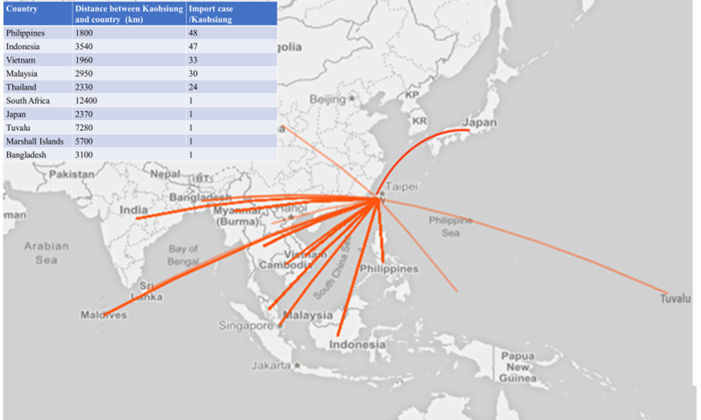

Supplementary Figure 1. Map showing the distance between the top/ bottom 5 countries from which Dengue was imported and Kaohsiung city between 2013 and 2018.

